**Ideation Phase**

**Define the Problem Statement**

|  |  |
| --- | --- |
| Date | 25 November 2025 |
| Team ID |  |
| Project Name | BookStore |
| Maximum Marks | 2 Marks |

**Problem statement:**

Customers often struggle to find the books they want due to cluttered catalogs, limited search options, and inconsistent product information across online bookstores. They face difficulty comparing books, reading reliable reviews, and discovering relevant recommendations. On the other hand, administrators and store owners find it hard to manage book inventory, update listings, track orders, and maintain categories efficiently because of outdated or scattered systems. This results in frustration for readers, inefficiency for admins, and a poor overall browsing and purchasing experience. BookSpot aims to solve these issues by offering a clean, organized, and user-friendly online bookstore with powerful search, personalized recommendations, and efficient admin controls.

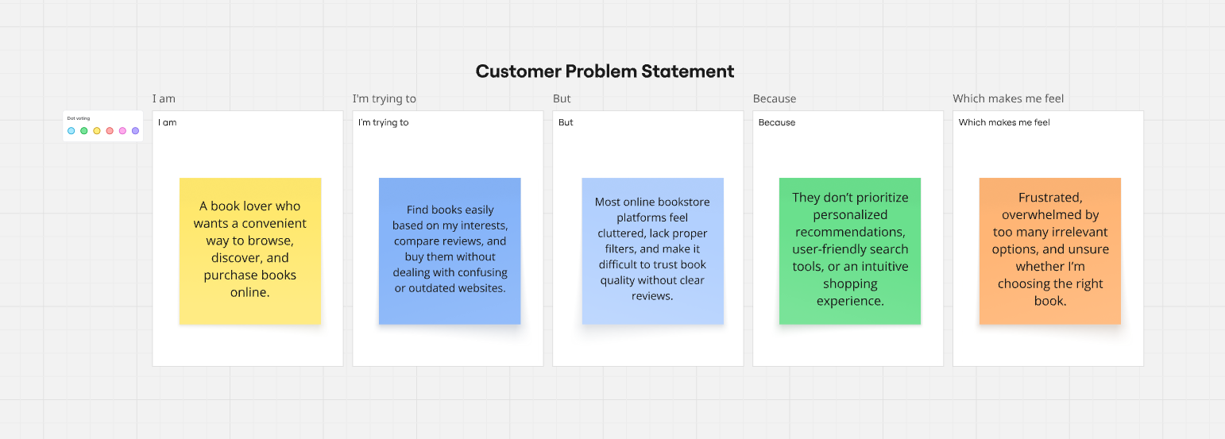

### Customer Problem Statement 1: User

**I am**  
A book lover who wants a convenient way to browse, discover, and purchase books online.

**I’m trying to**  
Find books easily based on my interests, compare reviews, and buy them without dealing with confusing or outdated websites.

**But**  
Most online bookstore platforms feel cluttered, lack proper filters, and make it difficult to trust book quality without clear reviews.

**Because**  
They don’t prioritize personalized recommendations, user-friendly search tools, or an intuitive shopping experience.

**Which makes me feel**  
Frustrated, overwhelmed by too many irrelevant options, and unsure whether I’m choosing the right book.

### Customer Problem Statement 2: Admin

**I am**  
A bookstore admin who wants a simple and efficient way to manage the store’s content and operations.

**I’m trying to**  
Add and update books, organize categories, manage orders, and maintain accurate inventory with ease.

**But**  
Current systems are scattered, require too much manual work, and often lead to errors or outdated information.

**Because**  
There is no centralized, user-friendly dashboard that streamlines book management and automates repetitive tasks.

**Which makes me feel**  
Stressed, inefficient, and concerned about delivering a poor shopping experience to customers.